Programing Assignment 4

**Problem 1:**

Global Parameters:

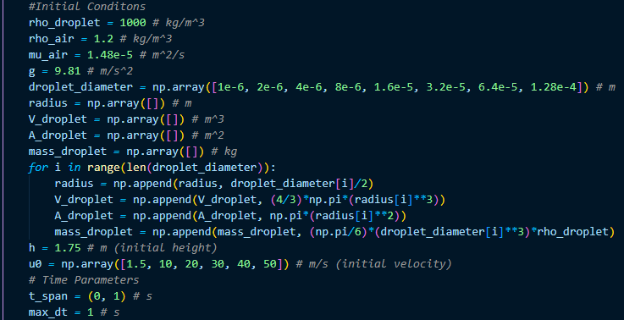

Plot showing vertical distance traveled over time

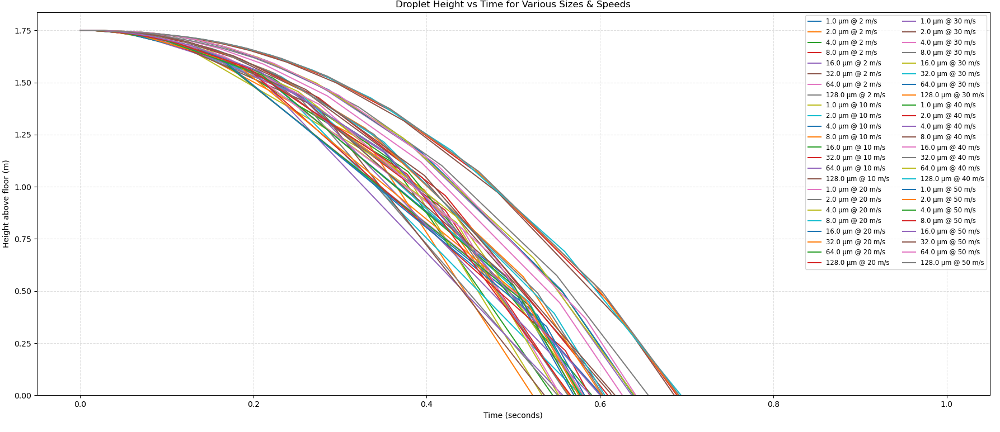

Table showing distance traveled:

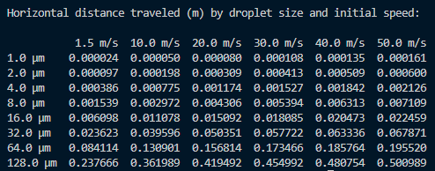

Table showing time to hit ground:

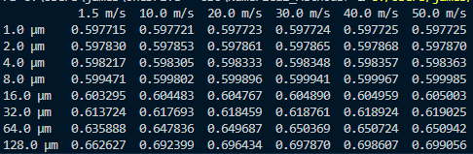

I used the built in RK45 to conduct my ODE calculations as shown:

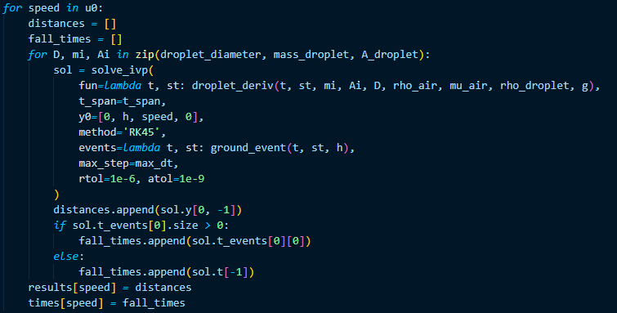

For my time step I determined 1 to be the best number in a range of 0-1 due to the fact that most of my droplets where hitting the floor, before the 1 second mark, as well as anything smaller than the 1 step, took my computer and excessively long time to run, over 15 minutes and no results, so I concluded that this would be the best step size, which resulted in fairly clean results. I do realize that I am probably missing a couple different droplet sizes and speeds, but this was what my computer was able to run.